Programming Fundamentals

Assignment 03

Course Code: CS1002

Syed Muhammad Shuja Ur Rahman

Roll No. 22K-4456

Sir Shehzad

**Question 1**

#include<stdio.h>

#include<string.h>

#include<stdlib.h>

int game(char id[]);

int main(){

printf("Syed Muhammad Shuja Ur Rahman\n22K-4456\n\n");

char id[4];

printf("Enter Last 4 Digits Of Your ID: ");

scanf("%s",&id);

printf("\n\n\t\t\t||=========Word Guess Game========||\n\n");

game(id);

}

int game(char id[]){

char array[5][6], word[6],ch,end[3];

int i,j,k,matched=0,score=0,flag=0;

restart:

for (i=0;i<5;i++)

{

for (j=0,k=0;j<6;j++,k++)

{

if(i==4 && j<4)

array[i][j]=id[k];

else

array[i][j]=(rand()%26+'A');

printf("\t%c\t",array[i][j]);

Sleep(100);

}

printf("\n\n");

}

again:

while(1)

{

fflush(stdin);

printf("\nEnter the word you want to search: ");

gets(word);

if (strcmpi(word,"END")==0)

{

printf("Game ended... Do you want to play again?(Y/N)");

scanf("%c",&ch);

if ( ch=='y' || ch== 'Y' )

goto restart;

else

exit(1);

}

else goto search;

}

search:

// SEARCHING FOR THE WORD ROW WISE...

for(i=0;i<5;i++)

{

for(j=0;j<6;j++)

{

if(word[matched]==array[i][j])

{

matched++;

if ( matched == strlen(word) )

{

score++;

printf("%s is present\nYour score is: %d\n",word,score);

flag=1;

break;

}

else continue;

}

else matched=0;

}

}

// SEARCHING FOR THE WORD COLUMN WISE...

if ( flag!= 1)

{

for(j=0;j<6;j++)

{

for(i=0;i<5;i++)

{

if ( word[matched]== array[i][j])

{

matched ++ ;

if( matched == strlen(word) )

{

score++;

printf("%s is present\nYour score is: %d\n",word,score);

flag=1;

break;

}

else continue;

}

else

matched=0;

}

}

}

if(flag!=1)

{

score--;

printf("%s is NOT present\nYour score is: %d\n",word,score);

}

flag=0;

goto again;

}

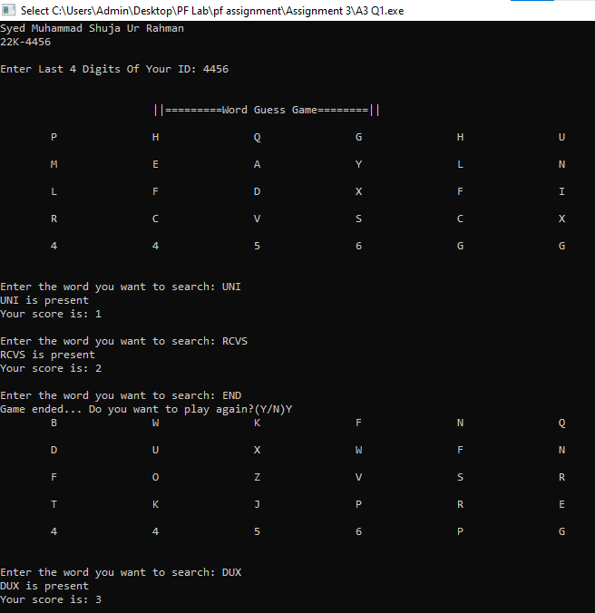

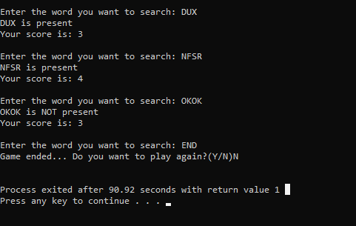

**Question: 2**

#include<stdio.h>

#include<string.h>

void encrypt(char str[]);

main(){

printf("Syed Muhammad Shuja Ur Rahman\n22K-4456\n\n");

char name[15],id[8],sec[2];

fflush(stdin);

printf("enter name: ");

scanf("%s",&name);

fflush(stdin);

printf("enter ID: ");

scanf("%s",&id);

printf("Section: ");

scanf("%s",&sec);

int x,i; char str[50];

fflush(stdin);

printf("Enter any sentence: ");

gets(str);

char newStr[20][20];

int letter=0; int words=0;

for(i=0;i<=(strlen(str));i++){

if(str[i]==' ' || str[i]=='\0'){

newStr[words][letter]='\0';

words++;

letter=0;

}

else{

newStr[words][letter]=str[i];

letter++;

}

}

}

**Question: 3**

#include<stdio.h>

#include<string.h>

#include<stdlib.h>

#include<unistd.h>

int yourID;

int students;

struct stdnt{

char id[8];

char name[20];

float mid1,mid2,final,assignment, quiz;

} s[];

int total_score=100;

float accumulateEvaluation(int);

float getGPA(float student_score, float total_score);

void replace();

void smartfind(char str_find[]);

void stats();

void main(){

printf("Syed Muhammad Shuja Ur Rahman\n22K-4456\n\n");

int yourID;

printf("Enter ID: ");

scanf("%d",&yourID);

students=yourID%1000;

printf("Total Students: %d\n",students);

int i,j, ch; float gpa;

char id[8],str_find[20];

for(i=0;i<students;i++)

{

printf("||=====Details of Student %d=====||\n",i+1);

ID:

printf("ID: ");

fflush(stdin);

gets(s[i].id);

for(j=0;j<i;j++)

{

if(strcmp(s[i].id,s[j].id)==0)

{

printf("This ID already exist... Please enter other student ID.\n");

goto ID;

}

else continue;

}

printf("Name: ");

gets (s[i].name);

mid_1:

printf("Mid 1 marks: ");

scanf("%f",&s[i].mid1);

if (s[i].mid1>15)

{

printf("invalid input...\n");

goto mid_1;

}

mid_2:

printf("Mid 2 marks: ");

scanf("%f",&s[i].mid2);

if (s[i].mid2>15)

{

printf("invalid input...\n");

goto mid_2;

}

finals:

printf("Finals: ");

scanf("%f",&s[i].final);

if(s[i].final>50)

{

printf("invalid input...\n");

goto finals;

}

Quiz:

printf("Quiz marks: ");

scanf("%f",&s[i].quiz);

if(s[i].quiz>10)

{

printf("invalid input...\n");

goto Quiz;

}

assn:

printf("Assignments: ");

scanf("%f",&s[i].assignment);

if(s[i].assignment>10)

{

printf("invalid input...\n");

goto assn;

}

printf("\n");

}

getch();

system("cls");

printf("Syed Muhammad Shuja Ur Rahman\n22K-4456\n\n");

printf("\nPress [g] to calculate GPA of a student\n");

printf("Press [a] to calculate GPA of all students\n");

printf("Press [r] to replace the details of student\n");

printf("Press [f] to find details of the student\n");

printf("Press [s] to print the stats of the class\n");

printf("Press [e] to exit the program\n");

while(1){

printf("\nPress Above Mentioned Keys To Perform Desired Task: ");

fflush(stdin);

scanf("%c",&ch);

switch (ch)

{

case 'g':

printf("Syed Muhammad Shuja Ur Rahman\n22K-4456\n\n");

printf("Enter id for gpa: ");

scanf("%s",&id);

for(i=0;i<students;i++)

{

if (strcmp(id,s[i].id)==0)

{

gpa=accumulateEvaluation(i);

printf("Student %s got %0.2f\n",id,gpa);

}

}

break;

case 'a':

printf("Syed Muhammad Shuja Ur Rahman\n22K-4456\n\n");

printf("\t\t____________________________________________\n");

printf("\t\t||============GPA OF ALL STUDENTS=========||\n\n");

printf("\t\t____________________________________________\n");

printf("\t\tNAME:\t\tID:\t\tGPA:\n");

for(i=0;i<students;i++)

{

gpa=accumulateEvaluation(i);

printf("\t\t%s\t\t%s\t\t%0.2f\n",s[i].name,s[i].id,gpa);

}

break;

case 'r':

printf("Syed Muhammad Shuja Ur Rahman\n22K-4456\n\n");

replace();

break;

case 'f':

printf("Syed Muhammad Shuja Ur Rahman\n22K-4456\n\n");

printf("Enter ID or Name to find Details of specific student: ");

scanf("%s",&str_find);

smartfind(str_find);

break;

case 's':

printf("Syed Muhammad Shuja Ur Rahman\n22K-4456\n\n");

printf("\t\t______________________________________\n");

printf("\t\t||=======STATS OF WHOLE CLASS=======||\n\n");

printf("\t\t______________________________________\n");

stats();

break;

case 'e': exit(1);

default:

printf("invalid choice...\n");

}

}

}

float accumulateEvaluation(int j){

float student_score,gpa;

student_score=s[j].mid1+s[j].mid2+s[j].final+s[j].assignment+s[j].quiz;

gpa=getGPA(student_score,total_score);

return gpa;

}

float getGPA(float student_score, float total_score ){

float gpa,percentage;

percentage = (student_score*100.0)/total_score;

if (percentage>= 86 && percentage<=100)

gpa=4.0;

else if (percentage>= 82 && percentage<86)

gpa=3.66;

else if (percentage>= 78 && percentage<82)

gpa=3.33;

else if (percentage>= 74 && percentage<78)

gpa=3.0;

else if (percentage>= 70 && percentage<74)

gpa=2.66;

else if (percentage>= 66 && percentage<70)

gpa=2.33;

else if (percentage>= 62 && percentage<66)

gpa=2.0;

else if (percentage>= 58 && percentage<62)

gpa=1.66;

else if (percentage>= 54 && percentage<58)

gpa=1.33;

else if (percentage>= 50 && percentage<54)

gpa=1.0;

else

gpa=0;

return gpa;

}

void replace(){

int i,j;

printf("Which index you wanto update? ");

scanf("%d",&i);

printf("ID: ");

fflush(stdin);

gets(s[i].id);

printf("Name: ");

gets (s[i].name);

printf("Mid 1 marks: ");

scanf("%f",&s[i].mid1);

printf("Mid 2 marks: ");

scanf("%f",&s[i].mid2);

printf("Finals: ");

scanf("%f",&s[i].final);

printf("Quiz marks: ");

scanf("%f",&s[i].quiz);

printf("Assignments: ");

scanf("%f",&s[i].assignment);

printf("\nUpdating");

Sleep(500);

printf(".");

Sleep(500);

printf(".");

Sleep(500);

printf(".");

printf("Successfully updated...");

for(j=i;j<i+1;j++)

{

printf("\nStudent ID: %s\n", s[i].id);

printf("Name: %s\n",s[i].name);

printf("Mid 1 marks: %0.2f\n",s[i].mid1);

printf("Mid 2 marks: %0.2f\n",s[i].mid2);

printf("Finals: %0.2f\n",s[i].final);

printf("Quiz marks: %0.2f\n",s[i].quiz);

printf("Assignments: %0.2f\n",s[i].assignment);

}

}

void smartfind(char str_find[]){

int i;float gpa;

for(i=0;i<students;i++)

{

if (strcmp(str_find,s[i].id)==0 || strcmp(str_find,s[i].name)==0)

{

printf("\nStudent ID: %s\n", s[i].id);

printf("Name: %s\n",s[i].name);

printf("Mid 1 marks: %0.2f\n",s[i].mid1);

printf("Mid 2 marks: %0.2f\n",s[i].mid2);

printf("Finals: %0.2f\n",s[i].final);

printf("Quiz marks: %0.2f\n",s[i].quiz);

printf("Assignments: %0.2f\n",s[i].assignment);

gpa=accumulateEvaluation(i);

printf("GPA: %0.2f\n",gpa);

}

}

}

void stats(){

int i;

float sum_mid1=0, avg_mid1, sum_mid2=0, avg_mid2, sum_final=0, avg_final;

float each_stdnt_total_score[students], max;

char id[10];

printf("\t\tStudent Count: %d\n",students);

for (i=0;i<students;i++)

{

sum_mid1 += s[i].mid1;

sum_mid2 += s[i].mid2;

sum_final += s[i].final;

each_stdnt_total_score[i] = s[i].mid1+s[i].mid2+s[i].final+s[i].assignment+s[i].quiz;

if(each_stdnt_total_score[i]>max)

{

max=each_stdnt_total_score[i];

strcpy(id,s[i].id);

}

}

avg_mid1 = sum_mid1 / students;

avg_mid2 = sum_mid2 / students;

avg_final = sum_final / students;

printf("\t\tAVERAGE OF MID 1 SCORE : %0.2f\n",avg_mid1);

printf("\t\tAVERAGE OF MID 2 SCORE : %0.2f\n",avg_mid2);

printf("\t\tAVERAGE OF FINAL SCORE : %0.2f\n\n",avg_final);

printf("\t\tStudent ID %s has the maximum score of %0.2f\n", id, max);

printf("\t\t_____________________________________________\n");

printf("\t\tLIST OF STUDENTS ID WHO DIDNT PASS THE COURSE\n");

printf("\t\t_____________________________________________\n");

for (i=0;i<students;i++)

{

if(each_stdnt_total_score[i]<50)

printf("\t\t\tStudent ID: %s\n\n\n",s[i].id);

}

printf("Thank you, my ID is 22k-4456 and my name is Shuja.\n");

}

